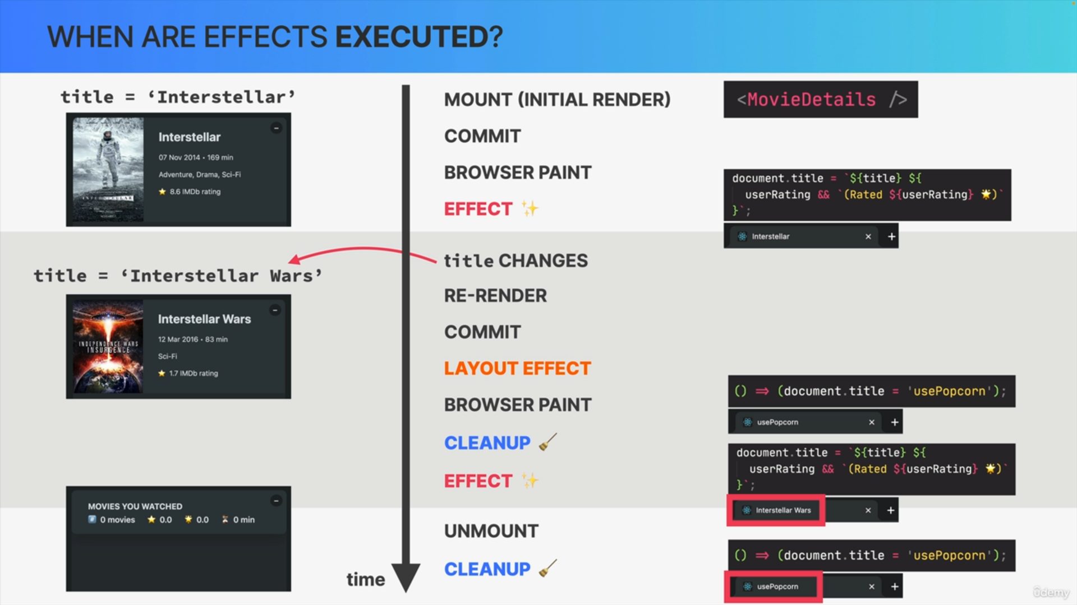

**Effect Cleanup Function**

* It allows executing code when a component unmounts.
* It's used to reset side effects, such as reverting the page title when a component unmounts.

**Execution of Cleanup Functions**

* They run before the effect is executed again, during re-renders, to clean up previous side effects.
* They also run right after the component unmounts.

**Usage of Cleanup Functions**

* Necessary when side effects persist after re-renders or unmounting, such as ongoing HTTP requests, which might lead to bugs like race conditions.
* Examples include canceling subscriptions, stopping timers, and removing event listeners.

**Best Practices for useEffect**

* Each useEffect should focus on a single task.
* Multiple effects can be created using multiple useEffect hooks to simplify understanding and cleanup.

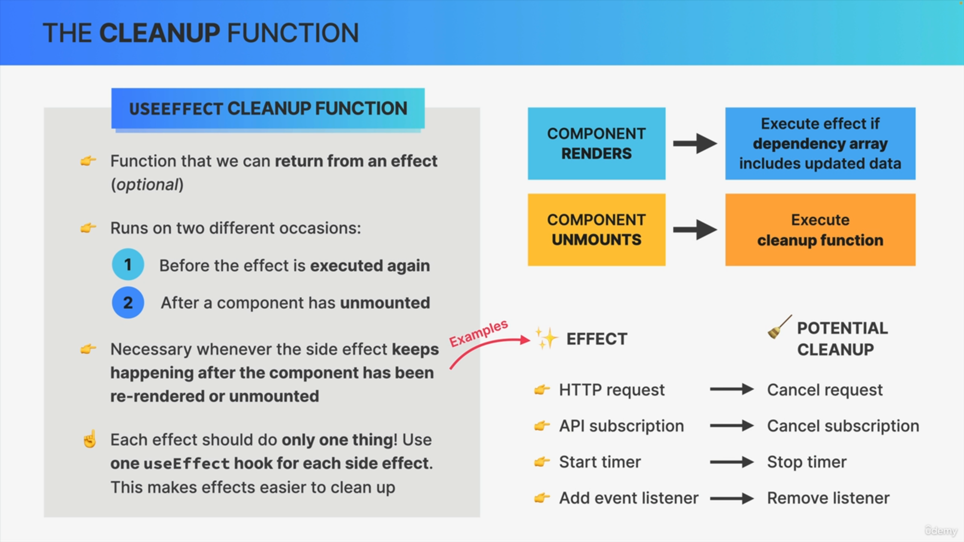

This comprehensive approach ensures proper handling of side effects and cleanup, covering the entire component lifecycle.